**Log in Form**

**Naka drop down ang button ang users iseselect nalang. Admin at User(BHW)**

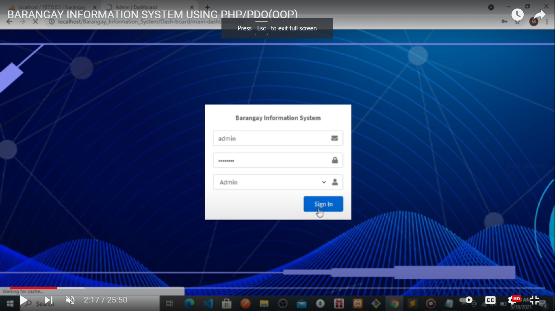

**ADMINISTRATOR PAGES:**

**\*\* ito pong home page ito po ung nasa Main page dati lipat lang po.**

Barangay Officials

Barangay Resident

Blotter Records

Barangay Records

Administrator

Forms

Certificates

Home

**WELCOME**

Dashboard

Slideshow

Vision

Mission

Copyright **© 2022 © Brgy. SalavanteUrbiztondo, Pangasinan. All rights reserved.**

Pwedesiya ma edit yung barangay information pati logo. clickable

Barangay Officials

Barangay Resident

Blotter Records

Barangay Records

Administrator

Forms

Certificates

Home

**WELCOME**

Barangay Officials

Total Residents

Total

Certificates

Total Blotter

More info.

More info.

More info.

More info.

Dashboard

Pag click makikitayung list ng records naka table at ready to print narin.

Copyright **© 2022 © Brgy. SalavanteUrbiztondo, Pangasinan. All rights reserved.**

Barangay Officials

Barangay Resident

Blotter Records

Barangay Records

Administrator

Forms

Certificates

Home

**WELCOME**

Ganonnalang po sir doon sagawaniyo po saYoutube.Pwede din lagyan ng pictures ng officials.

Dashboard

Barangay officials<

Copyright **© 2022 © Brgy. SalavanteUrbiztondo, Pangasinan. All rights reserved.**

Pag click yung isa ang lalabas

Add resident button

Barangay Records

Administrator

Forms

Certificates

Home

**WELCOME**

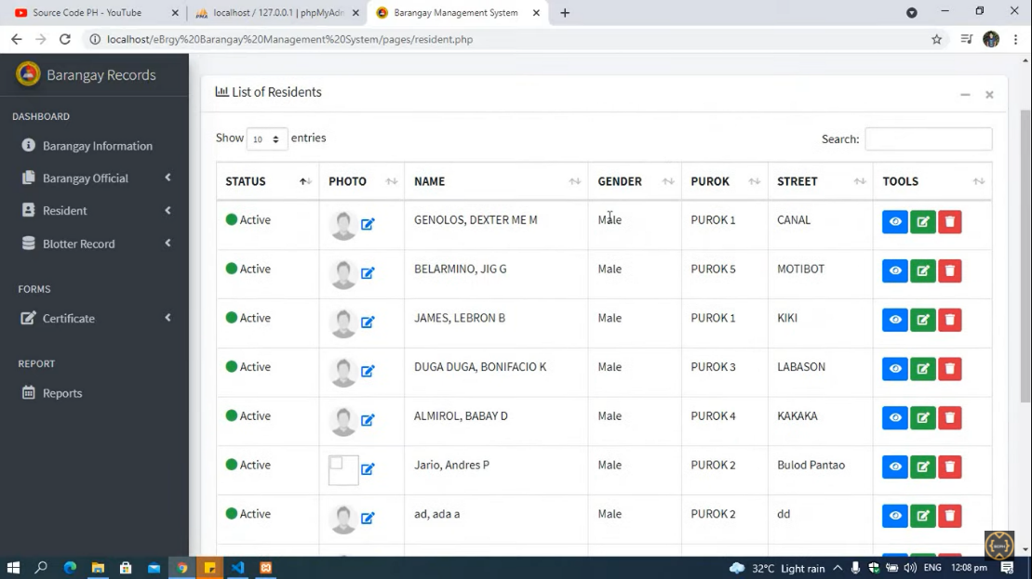

Yung form na need nai-fill same nalang doon sayoutube channel niyo po. Pero walanayung user and password at remarks. At pwedelagyan ng profile picture.

Dashboard

Barangay officials

Barangay Resident

**Resident list**

Barangay Blotter

Copyright **© 2022 © Brgy. SalavanteUrbiztondo, Pangasinan. All rights reserved.**

SA View and Edit button same ang makikitasafinill up na form sa add resident button.

Diba po makikita lahat ng personal info sa VIEW BUTTON taposmakikitanarin po yung case involved kung yung resident is my case record nasa barangay. Parang itong screenshot po.

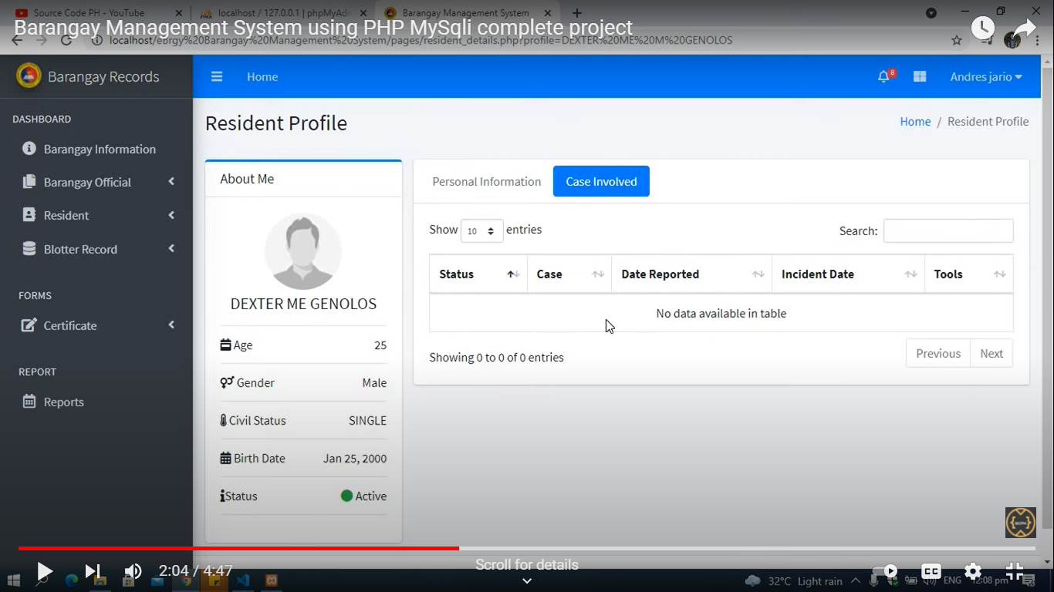

Barangay Records

Administrator

Forms

Certificates

Home

**WELCOME**

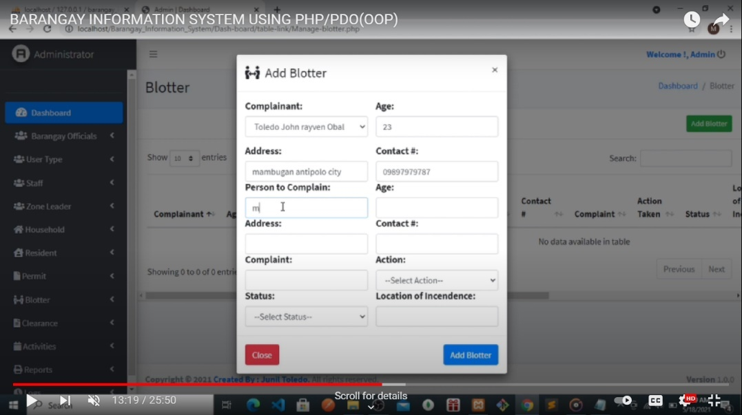

Dashboard

Barangay officials

Barangay Resident

Barangay Blotter

Copyright **© 2022 © Brgy. SalavanteUrbiztondo, Pangasinan. All rights reserved.**

Ganonnalang din po sayoutube channel niyo sir. Ditosa blotter po.

Barangay Records

Administrator

Forms

Certificates

**Issue Certificate**

Manage certificate

Home

**WELCOME**

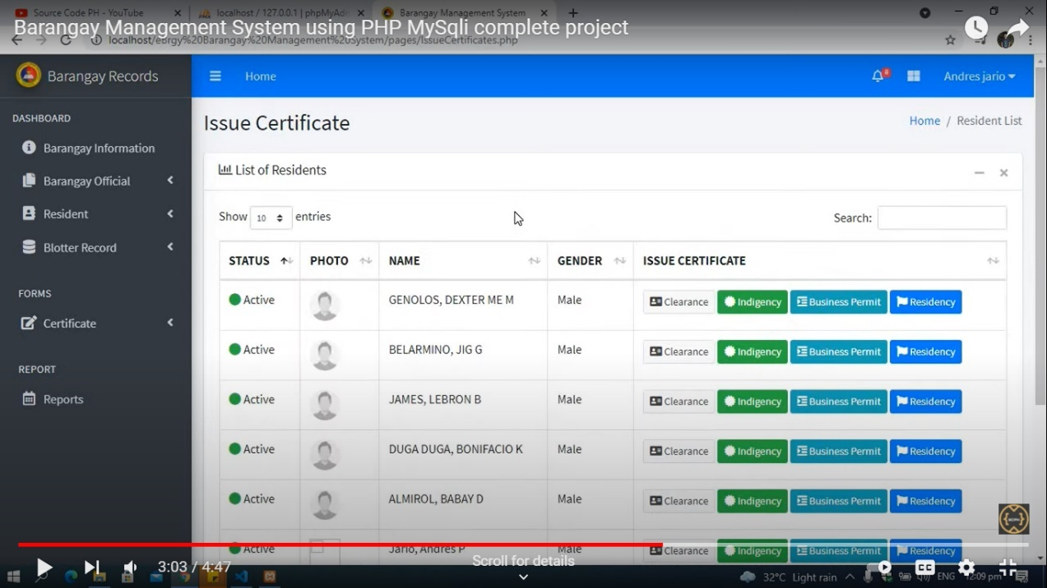

Dashboard

Barangay officials

Barangay Resident

Barangay Blotter

Copyright **© 2022 © Brgy. SalavanteUrbiztondo, Pangasinan. All rights reserved.**

Pag nag click ng kahitsaanna certificatesiyanito ang lalabas

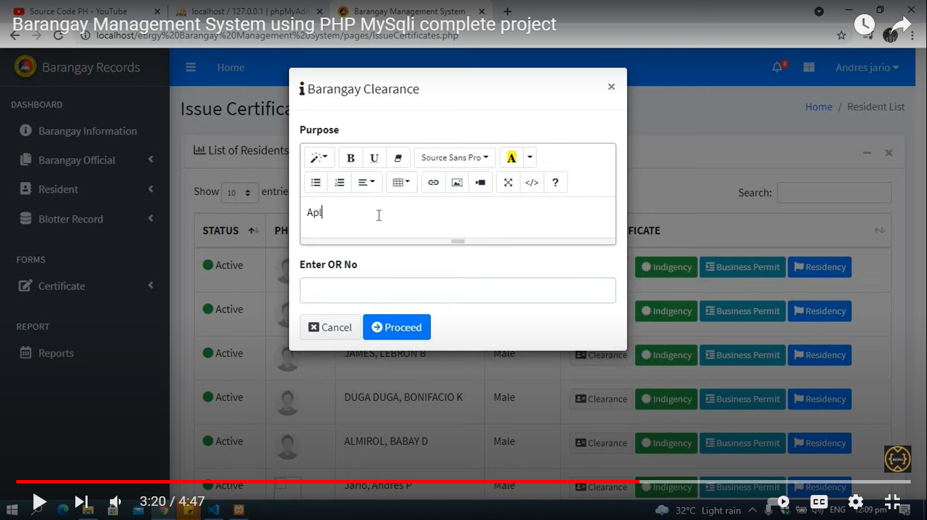

Barangay Records

Administrator

Forms

Certificates

Issue Certificate

**Manage certificate**

Home

**WELCOME**

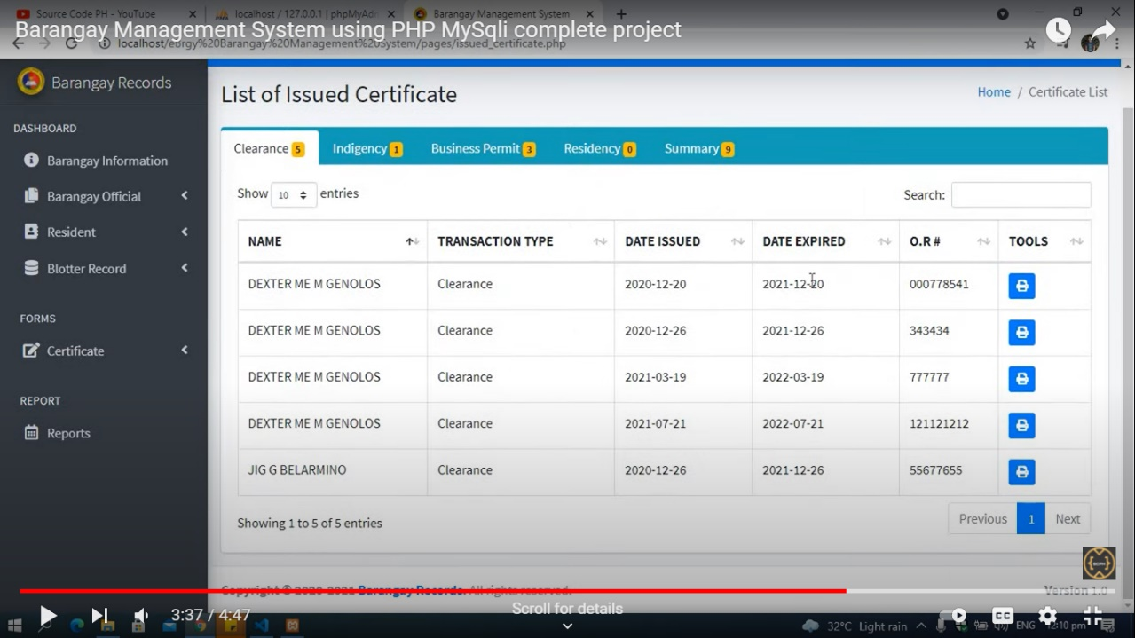

Dashboard

Barangay officials

Barangay Resident

Barangay Blotter

Copyright **© 2022 © Brgy. SalavanteUrbiztondo, Pangasinan. All rights reserved.**

Clickable at makikita kung ilangna ang request samga certificates samga to. At pwede ring ma print.

Print button. Pag click ready to print nasiya. Saka name naagadnung resident na nag request nakalagay.

Summary ng lahat ng request na certificates. Naka table.

For example:

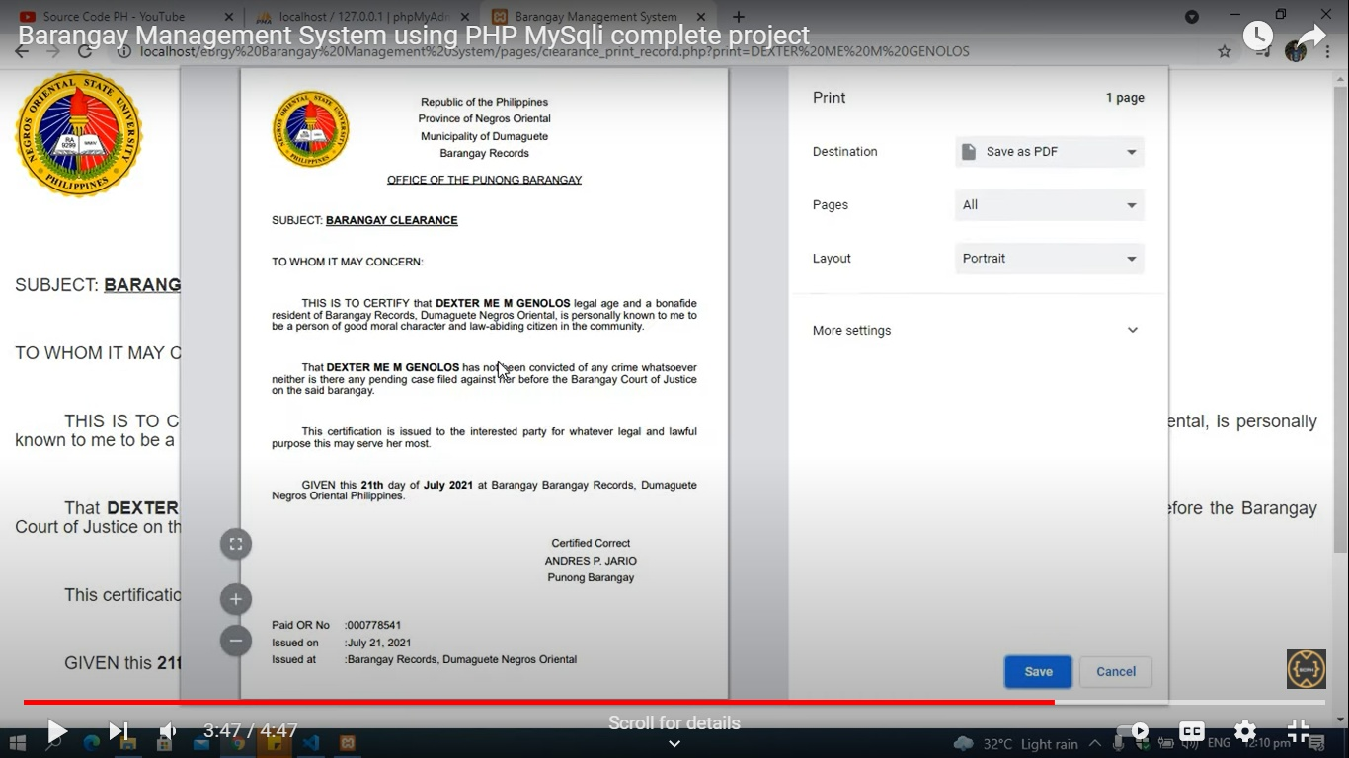

Para sa BHW

**home page ito po ung nasa Main page dati lipat lang po.**

Barangay Officials

Barangay Resident

Blotter Records

Barangay Records

Administrator

Forms

Certificates

Home

**WELCOME**

Dashboard

Slideshow

Vision

Mission

Copyright **© 2022 © Brgy. SalavanteUrbiztondo, Pangasinan. All rights reserved.**

Name ng account nunggagamit

Barangay Records

Name

Forms

Home

**WELCOME**

Barangay Health Workers list

Total Resident

Total

Certificates of Completion of Quarantine

Total Pregnant

Dashboard

Barangay Health Worker

More info.

More info.

More info.

More info.

Population survey

Total TB Referral Form

Barangay Resident

Total Child Record

More info.

More info.

More info.

Pregnancy Survey Form

OPT Plus Form 1

Covid Signs and symptoms Log form

TB Referral Form

YEAR:

ALL <

Copyright **© 2022 © Brgy. SalavanteUrbiztondo, Pangasinan. All rights reserved.**

Table nalang po ito sir. Kung anonakalagaysa table sir ganonnalang. Meron add, delete, and update

Barangay Records

Name

Forms

Home

**WELCOME**

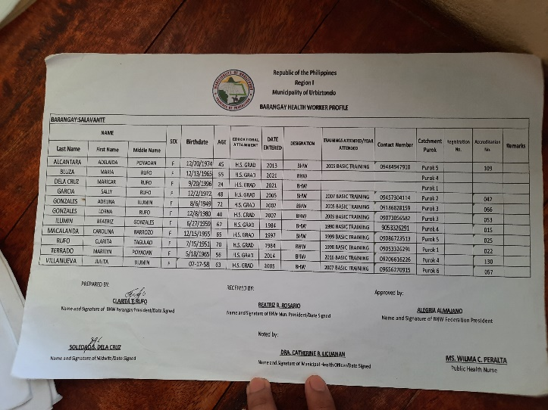

Dashboard

Barangay Health Worker

Barangay Resident

Pregnancy Survey Form

OPT Plus Form 1

Covid Signs and symptoms Log form

Copyright **© 2022 © Brgy. Salavante Urbiztondo, Pangasinan. All rights reserved.**

TB Referral Form

Barangay Records

Name

Forms

Home

**WELCOME**

Dashboard

Ganonnalang po sa Admin din.

Barangay Health Worker

Barangay Resident

Pregnancy Survey Form

OPT Plus Form 1

Covid Signs and symptoms Log form

Copyright **© 2022 © Brgy. Salavante Urbiztondo, Pangasinan. All rights reserved.**

TB Referral Form

Barangay Records

Name

Forms

Home

**WELCOME**

Kung ilan ang names na mag aappear.

Pag nag add mapupuntasamga list.

Add Mother/nanganak

Add Pregnant/manganganak

Show: 10

Dashboard

Show: 10

Search:

Mother/Nanganak List:

Search:

Pregnant/Manganganak List:

Barangay Health Worker

Barangay Resident

Pregnancy Survey Form

OPT Plus Form 1

Covid Signs and symptoms Log form

Copyright **© 2022 © Brgy. Salavante Urbiztondo, Pangasinan. All rights reserved.**

Total kung ilan ang na-add.

Total:

Total:

TB Referral Form

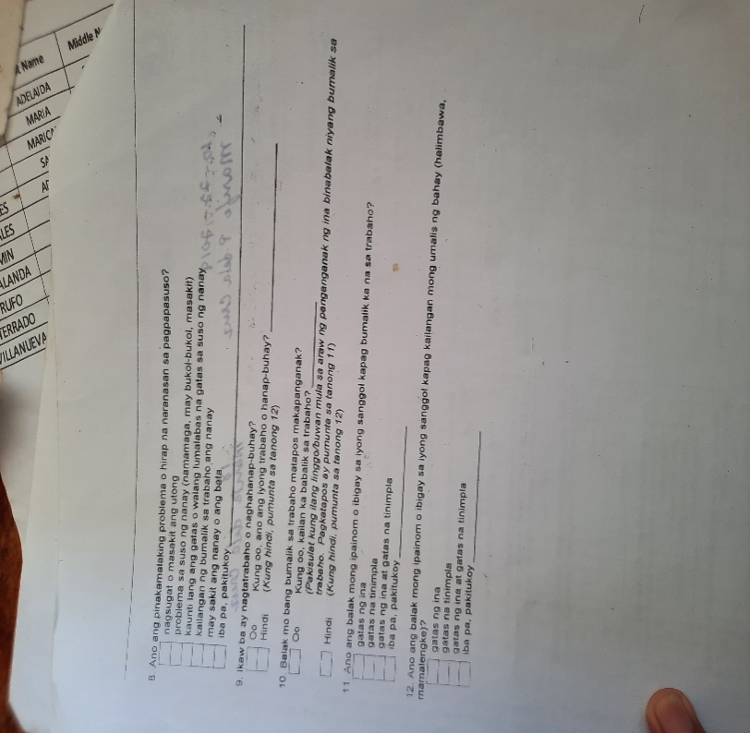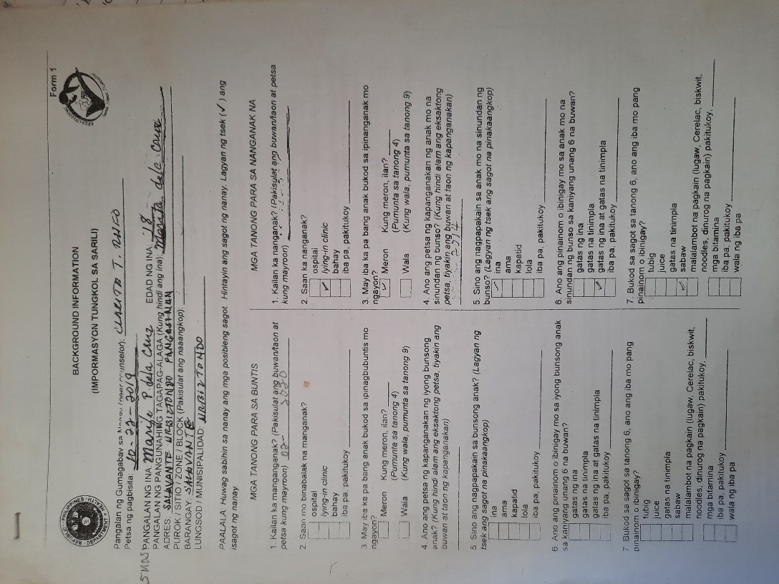

**Bago ma-add itomunasasagutan nil ana form. Form type siya. At itoyung un ana form sakanilanasasagutan.**

Unang form (Meron sakanilangdalawa)

May naibanailangtanong para sabuntis at sananganaknanandyanna po siya sir.

**Pangalawa na Form**

Para sa buntis/manganganak: Para sa Mother/Nanganak na

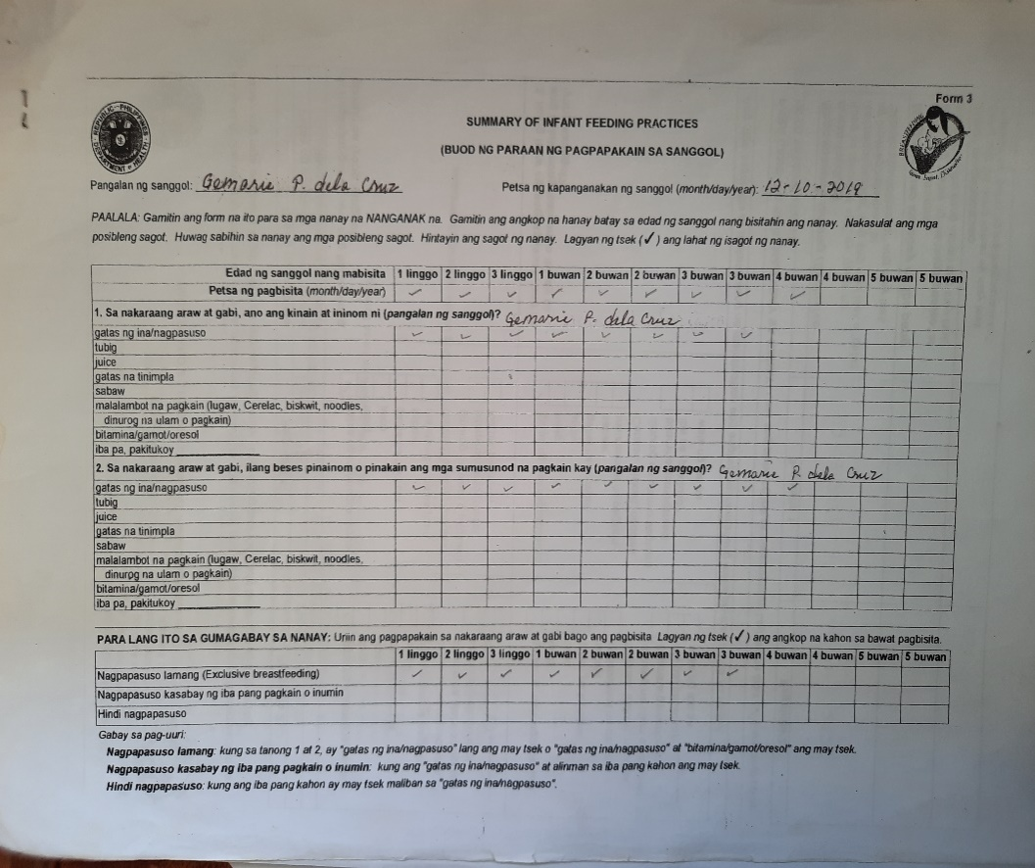

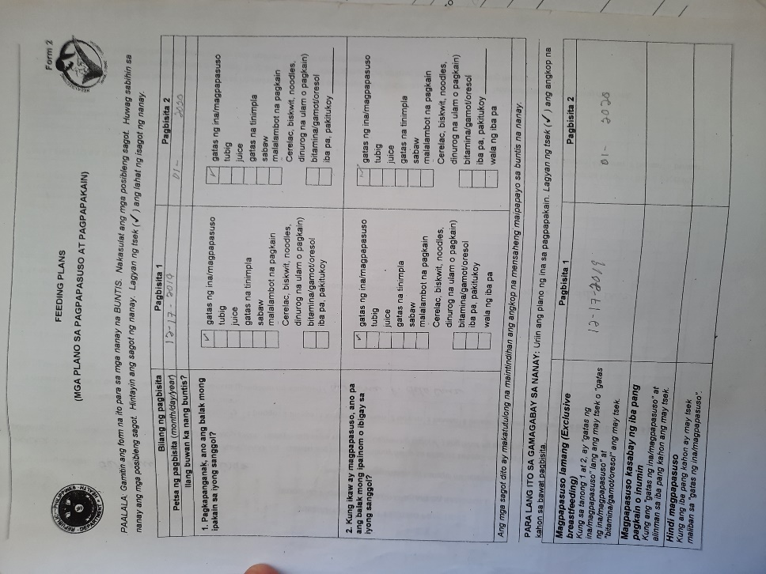

Pwederinsilangi-printitongmga form.

**SAMPLE PAG NA ADD NA AT READY TO PRINT**

Barangay Records

Name

Forms

Home

**WELCOME**

Add Mother/nanganak

Add Pregnant/manganganak

Pregnant/Manganganak List:

Mother/Nanganak List:

Dashboard

Barangay Health Worker

Auto alphabetically arrange siya at naka numbering din.

1. Castro, Alixa R.

Barangay Resident

Clickable ang name taposito ang next nalalabas.

Pregnancy Survey Form

OPT Plus Form 1

Covid Signs and symptoms Log form

Copyright **© 2022 © Brgy. Salavante Urbiztondo, Pangasinan. All rights reserved.**

TB Referral Form

Barangay Records

Name

Forms

Home

**WELCOME**

Pregnant/Manganganak List:

Dashboard

Search:

Show: 10 entries

Barangay Health Worker

Print Forms

Age

Name

Barangay Resident

25 years old

1. Castro, Alixa R.

Pag click niyo ready to print nayungmgasinagutannila. Yung screen shot yunna po yungformat

Print

Pregnancy Survey Form

OPT Plus Form 1

Covid Signs and symptoms Log form

TB Referral Form

Copyright **© 2022 © Brgy. Salavante Urbiztondo, Pangasinan. All rights reserved.**

Barangay Records

Name

Forms

Home

**WELCOME**

List of Preshoolers

Search:

Add Preschoolers:

Show: _ Entries

Dashboard

Age in Months

Barangay Health Worker

Child’s Full Name:

L name, F name MI

Name of the Mother or Caregiver:

Last name, First name MI

Gender:

Male or Female

Birth of Date:

MM/DD/YYYY

Weight

(Kg)

Height

(cm)

Barangay Resident

Pregnancy Survey Form

OPT Plus Form 1

Pag nag add ditomapupunta at ito lang angmgamakikita.

Covid Signs and symptoms Log form

Copyright **© 2022 © Brgy. Salavante Urbiztondo, Pangasinan. All rights reserved.**

TB Referral Form

Ito naman yungsasagutanna form. Form type po ulit. Pa lagaynalang po lahatn g mga need nasagutansa form.

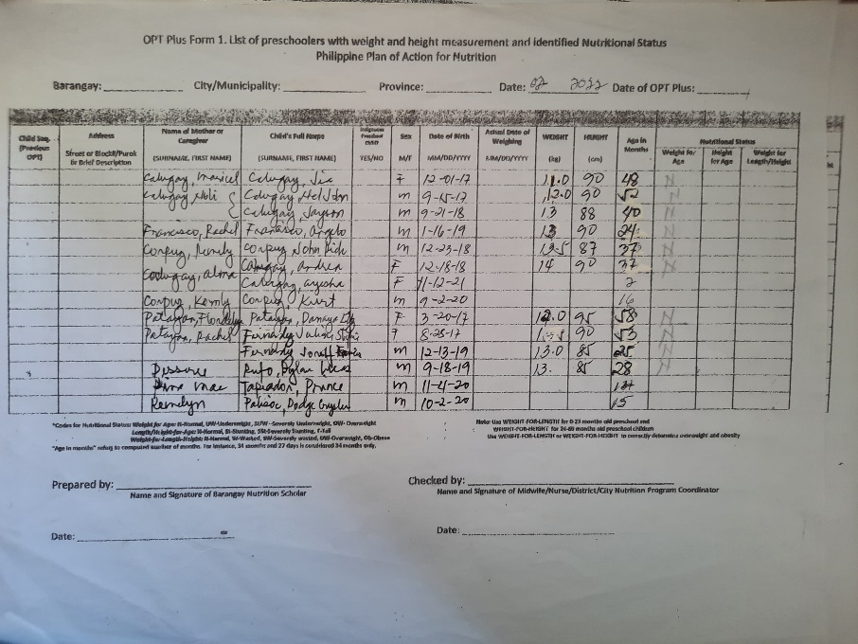

Barangay Records

Name

Forms

Home

**WELCOME**

List of PUM

Show _ Entries

Add PUM

Search:

Dashboard

Barangay Health Worker

Age

Gender

Name

End of Monitoring

(date)

Start of Monitoring

(date)

Purok

Status

Barangay Resident

Pregnancy Survey Form

EX.

OPT Plus Form 1

Purok 1

December 18, 2021

January 2, 2022

Male

46

Macalanda, Mike K.

Ongoing

Pwede mamili ng statis type. Kung Ongoing lahat ng on going makikita and vise versa.

Covid Signs and symptoms Log form

Copyright **© 2022 © Brgy. Salavante Urbiztondo, Pangasinan. All rights reserved.**

Status type: All, Ongoing, or Finished

TB Referral Form

Clickable yung name tapos makikita yung form na fifill up-an po.

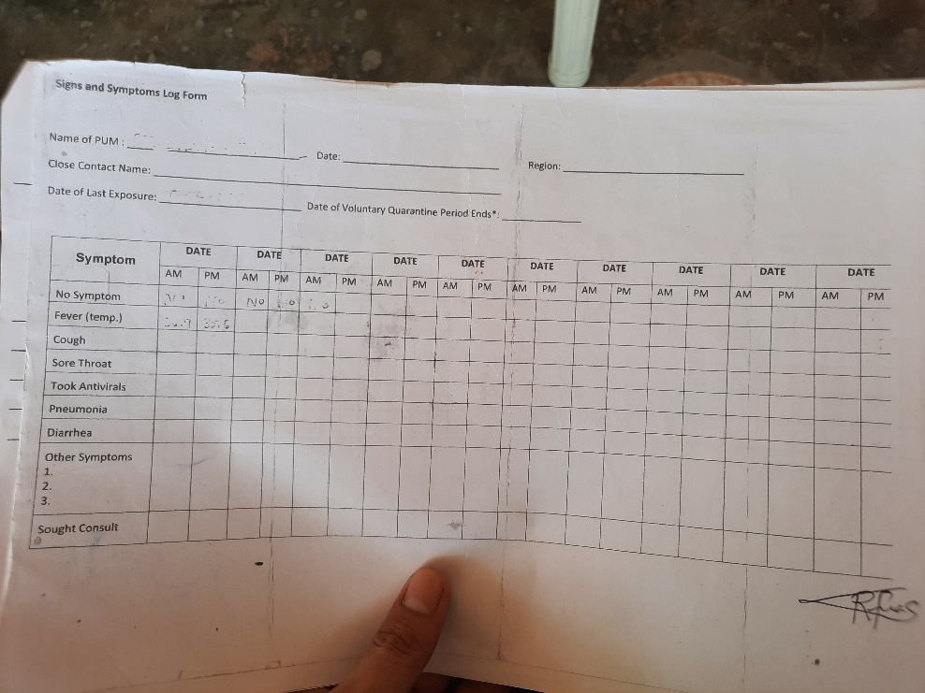

14 days po ito sir.

Button

Update

Close

**Ito pag na click na po siya**

Barangay Records

Name

Forms

Home

**WELCOME**

Dashboard

Barangay Health Worker

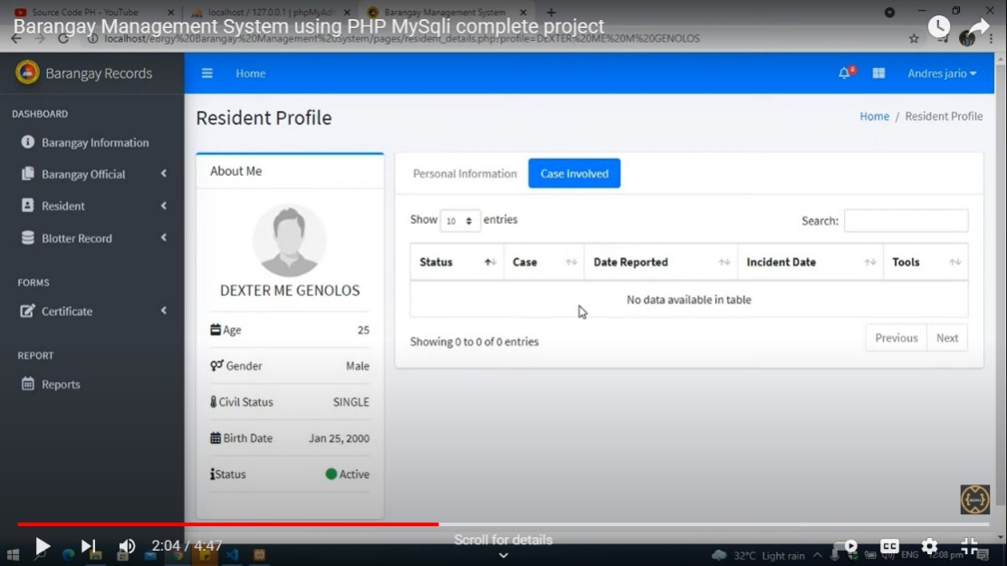

PUM Profile

PUM Profile

Barangay Resident

Personal Information

End of Monitoring

Start of Monitoring

Pregnancy Survey Form

**Print** Quarantine Certificate

Button

OPT Plus Form 1

Purok 1

Covid Signs and symptoms Log form

Copyright **© 2022 © Brgy. Salavante Urbiztondo, Pangasinan. All rights reserved.**

TB Referral Form

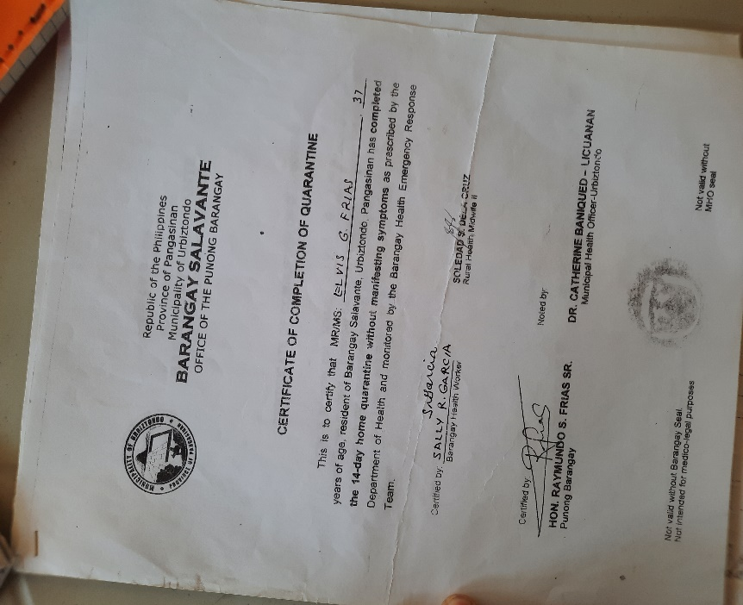

Barangay Records

Name

Forms

Home

**WELCOME**

List of TB Cases

Search

Add TB patient

Show _ Entries

Dashboard

Barangay Health Worker

Name

Gender

Age

Purok

Barangay Resident

Sa table sir lagi naka alphabetically arrange po at may numbering po.

Pregnancy Survey Form

OPT Plus Form 1

Covid Signs and symptoms Log form

Copyright **© 2022 © Brgy. Salavante Urbiztondo, Pangasinan. All rights reserved.**

TB Referral Form

Bago po siya ma add. Sasagutan na Niya po itong form para sa TB. Wala yung purok sa form pero padagdag nalang po sa tanong.

NASA BABA PO YUNG SCREEN SHOT.

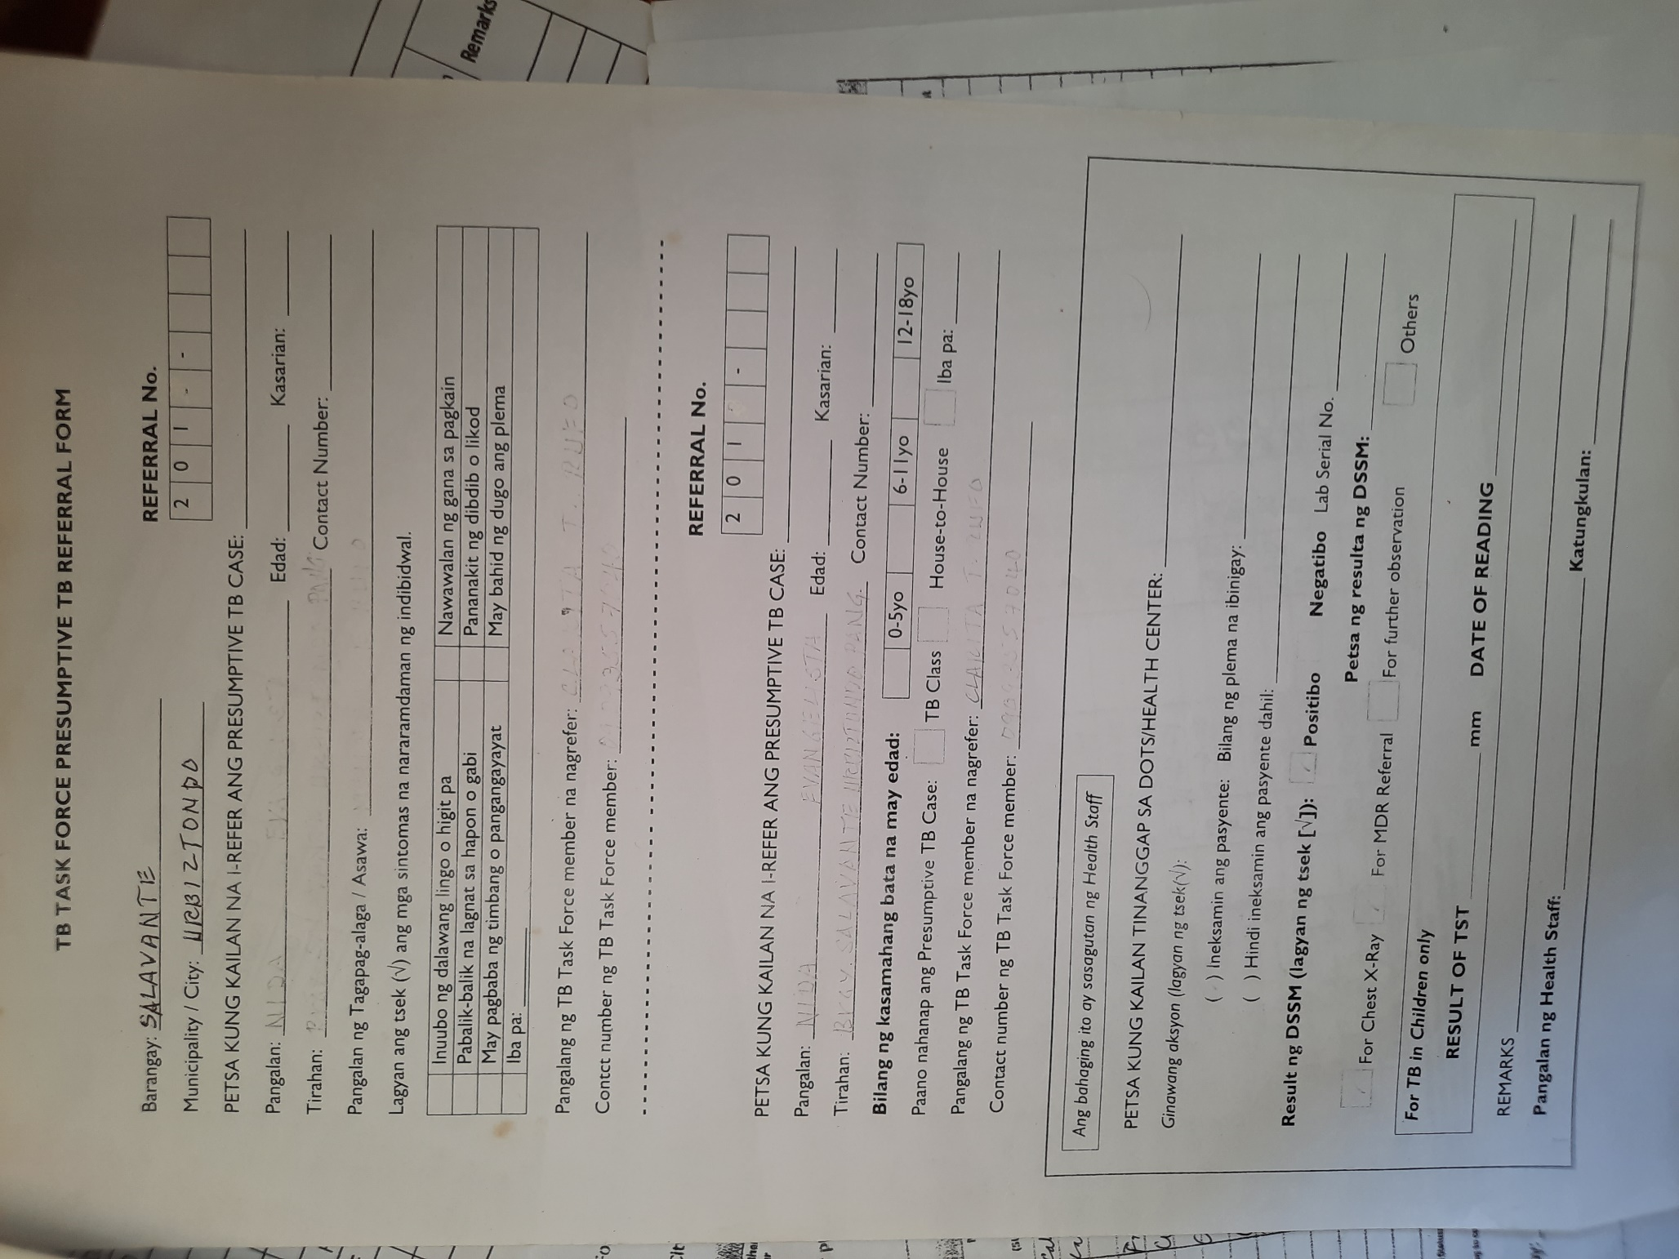

Barangay Records

Name

Forms

Home

**WELCOME**

Dashboard

Barangay Health Worker

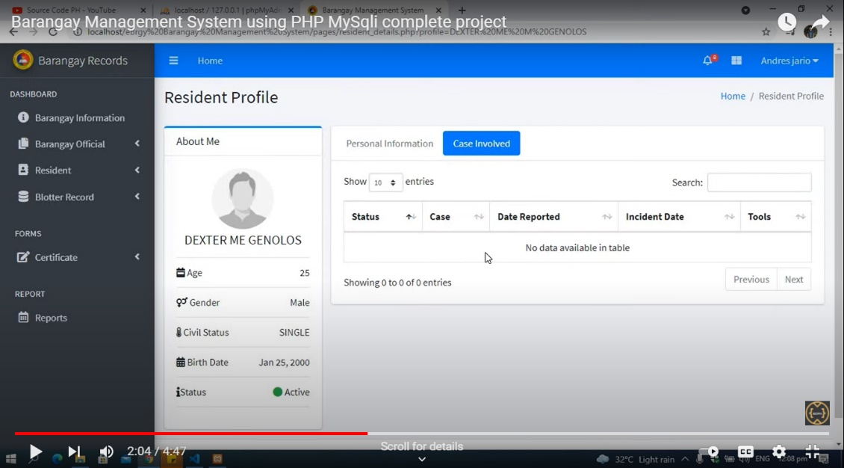

TB Patient Profile

Profile

Barangay Resident

Personal Information

End of Monitoring

Start of Monitoring

Pregnancy Survey Form

**Print** Quarantine Certificate

Button

OPT Plus Form 1

Purok 1

Covid Signs and symptoms Log form

Contact Number

Copyright **© 2022 © Brgy. Salavante Urbiztondo, Pangasinan. All rights reserved.**

Close

Print

Edit

TB Referral Form

Pag na edit and next na button nun is update.

I-print po yung form na, na fill up nila. Nasa taas po yung farmat po.